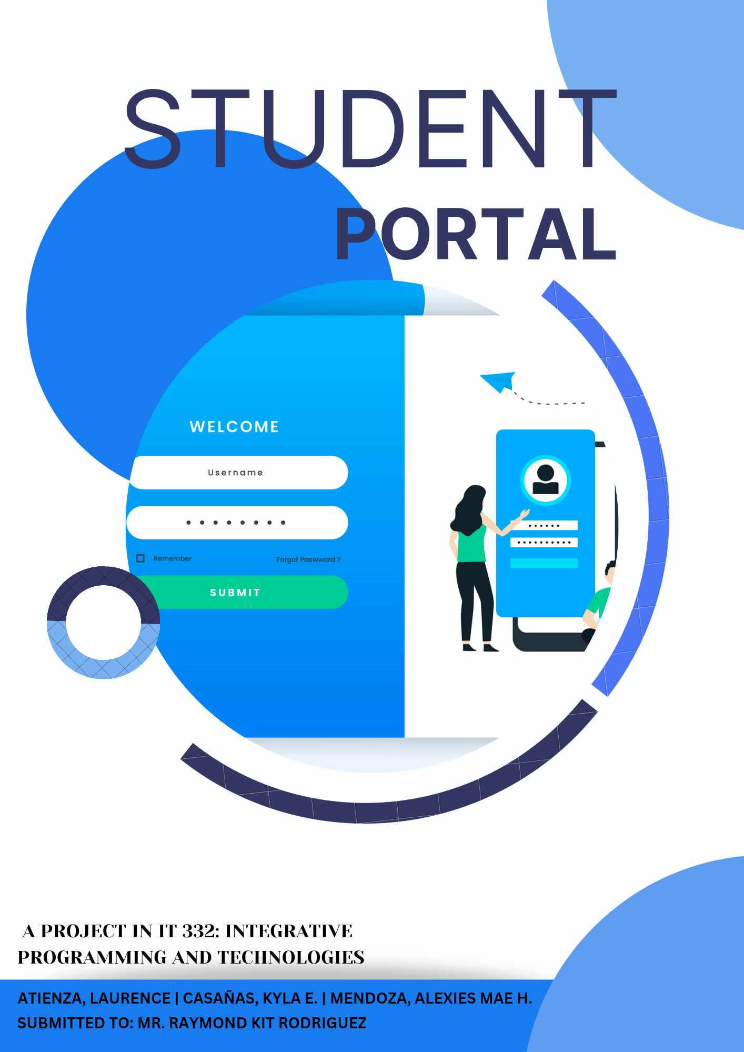

**STUDENT MANAGEMENT SYSTEM FOR PAHARANG INTEGRATED SCHOOL**

**PROJECT DESCRIPTION**

Managing the students takes a long time to work. The process they have is costly, time consuming and tiresome. It put a lot of pressure on teachers and administrator to always be accurate in all details of their work at all times. The problem being an admin and teacher aren’t perfect no matter how much they wish they were with their previous, they can encounter numerous problems in the service.

Paharang Integrated School, which is located at Paharang, Batangas City where there is a process of student management using paper based in managing and collecting the number of enrolled students.

In response, the team aim to design and develop a Student Management System that would provide users with their information. For the development of the project, tools such as Ionic framework.

**DEVELOPMENT MODEL**

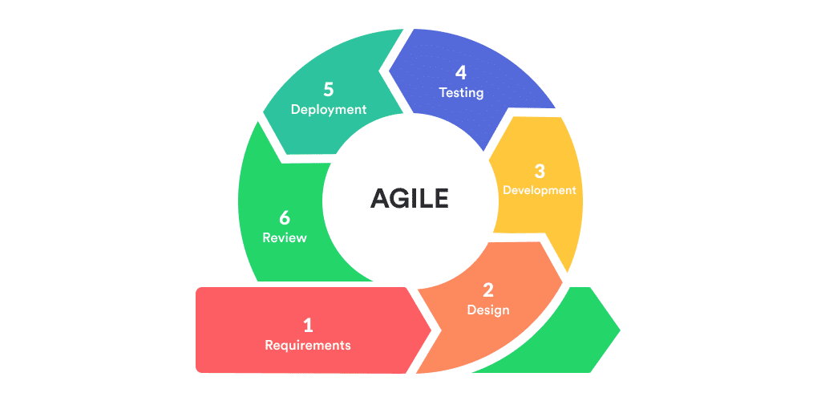

The team used the mobile app development lifecycle for the application development model, which includes the planning or initiation and requirement analysis phase, designing the application, development phase, application testing or debugging, launch or deployment, and review.

**IT 332: INTEGRATIVE PROGRAMMING AND TECHNOLOGIES**

**STUDENT MANAGEMENT SYSTEM FOR PAHARANG INTEGRATED SCHOOL**

**INITIATION AND REQUIREMENT ANALYSIS**

In this phase, the team first addressed the project's goal, which is to create a portal that provides information of the students. The system requirements intended by the team will be to provide the user with generate reports as well as a simple and easy-to-navigate user inter-face.

**DESIGNING THE APPLICATION**

In this phase, the team evaluate the requirements obtained as input to determine which software tools will be needed for development. A wireframe and mock-up design will also be utilized to demonstrate how the actual application structure would look. The team intend to make the application's graphical interface user-friendly and simple to use.

**DEVELOPMENT**

The team start creating code during this phase. A web-based project is successfully developed that is both consistent with the aims and capability of addressing the demands of the project's users. It was developed and designed in accordance with the requirements to enhance user experience, provide access to all necessary resources, strengthen security, and prevent mistakes.

**APP TESTING AND DEBUGGING**

Once the coding is complete, the team will run a series of tests throughout this phase to

check that the code is clean, and the Student Management system is bug-free, as well as that it has

achieved the requirements.

**LAUNCH**

After testing, the Mobile app Student Management will be launched so that users can access and use it.

**REVIEW/MONITORING**

The team intend to monitor or review any issues or problems that may occur on the Student Management system during this phase and attempt to resolve them.

**IT 332: INTEGRATIVE PROGRAMMING AND TECHNOLOGIES**

**STUDENT MANAGEMENT SYSTEM FOR PAHARANG INTEGRATED SCHOOL**

**SYSTEM ARCHITECTURE**

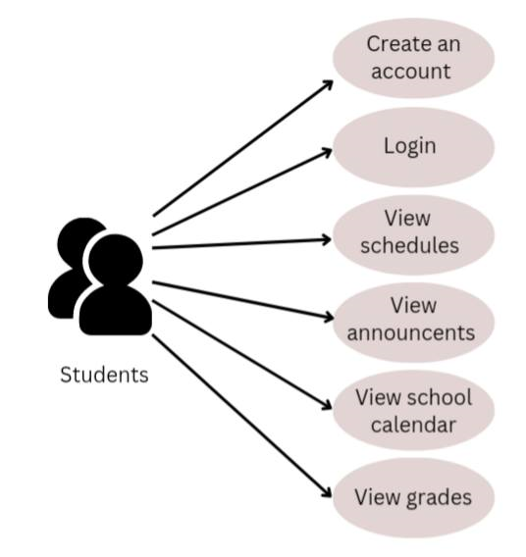

The team presents the diagrams above to illustrate the users' interaction in the application. It shows that the user must create an account to enter in the student portal. The system will validate their account hence, student can login in the portal and enter their information.

Another feature is that the user can view their schedules, grades, and announcements in the application.

**IT 332: INTEGRATIVE PROGRAMMING AND TECHNOLOGIES**

**STUDENT MANAGEMENT SYSTEM FOR PAHARANG INTEGRATED SCHOOL**

**GITLAB REPOSITORY**

**IT 332: INTEGRATIVE PROGRAMMING AND TECHNOLOGIES**

**STUDENT MANAGEMENT SYSTEM FOR PAHARANG INTEGRATED SCHOOL**

**APPLICATION SCREENSHOT**

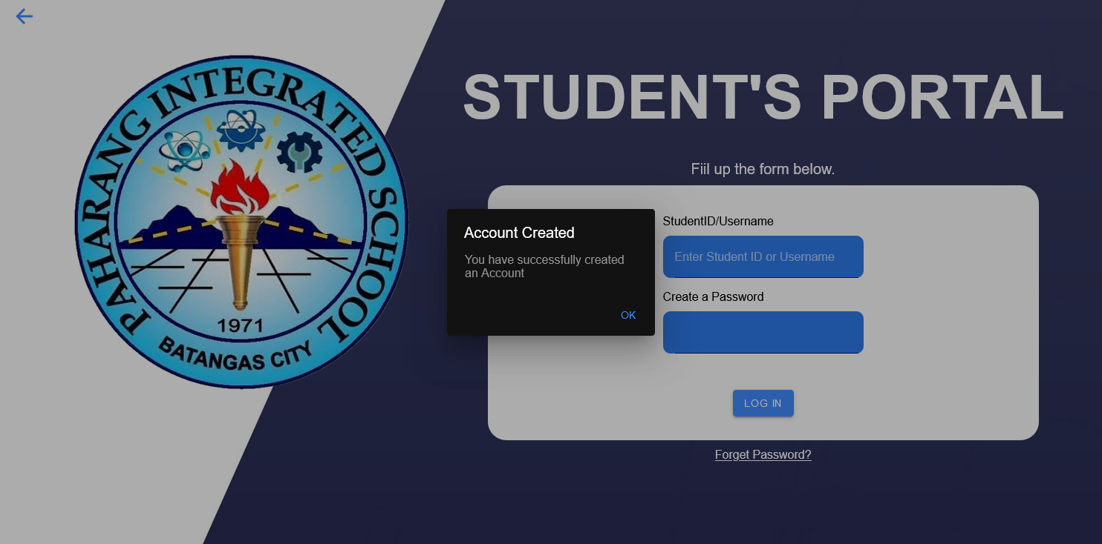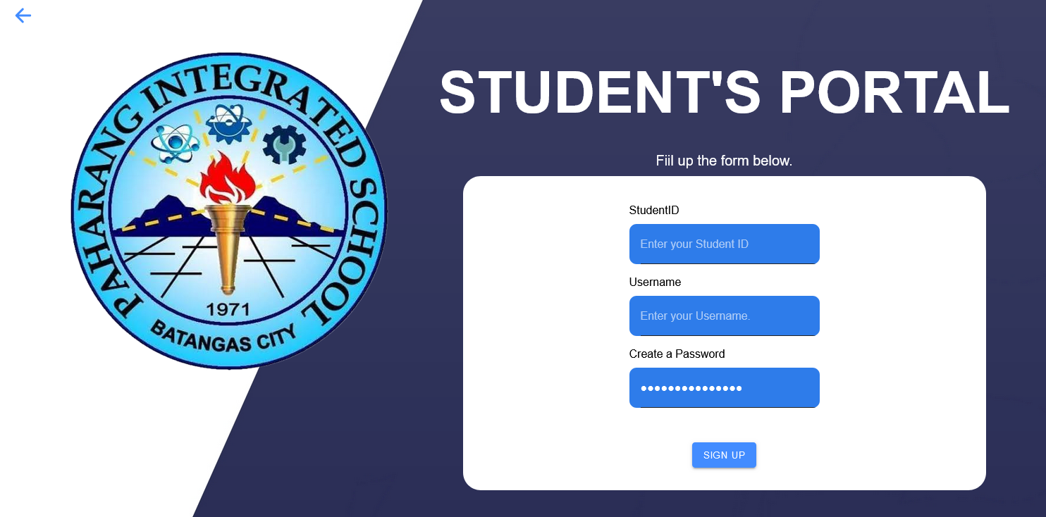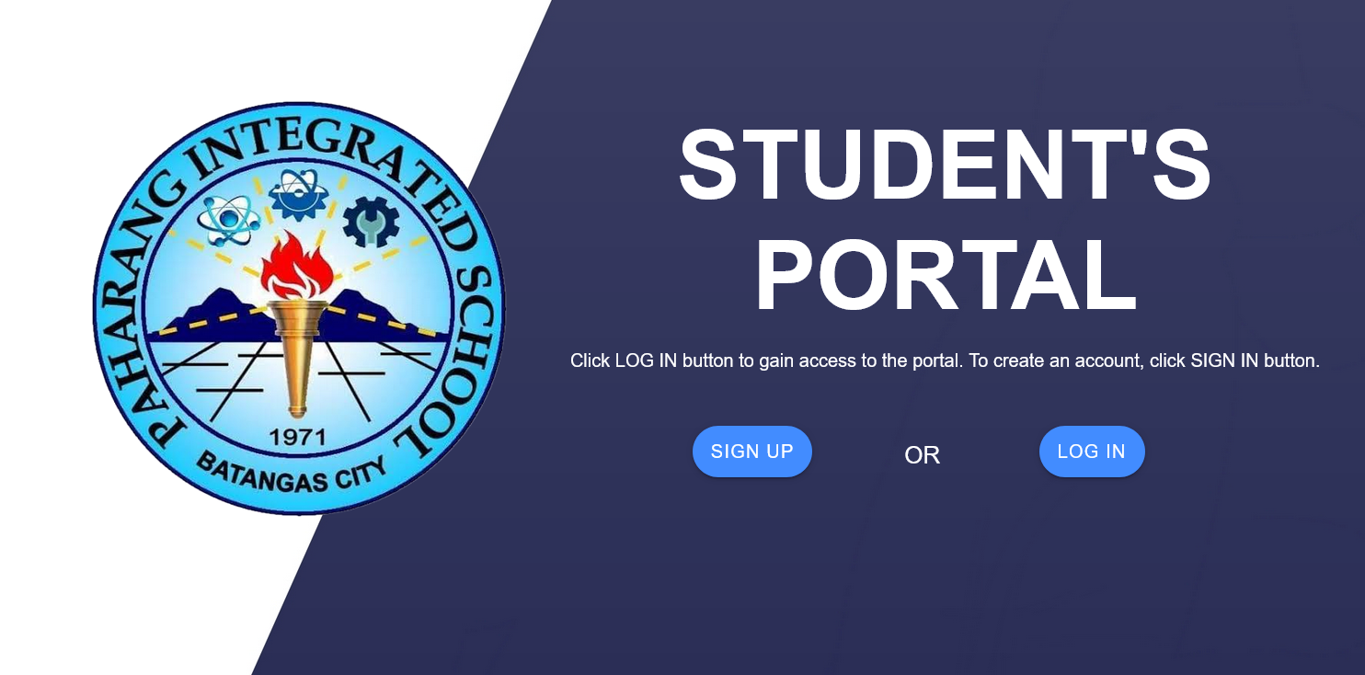

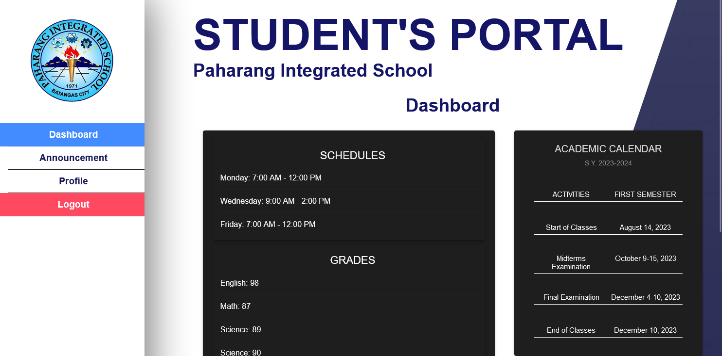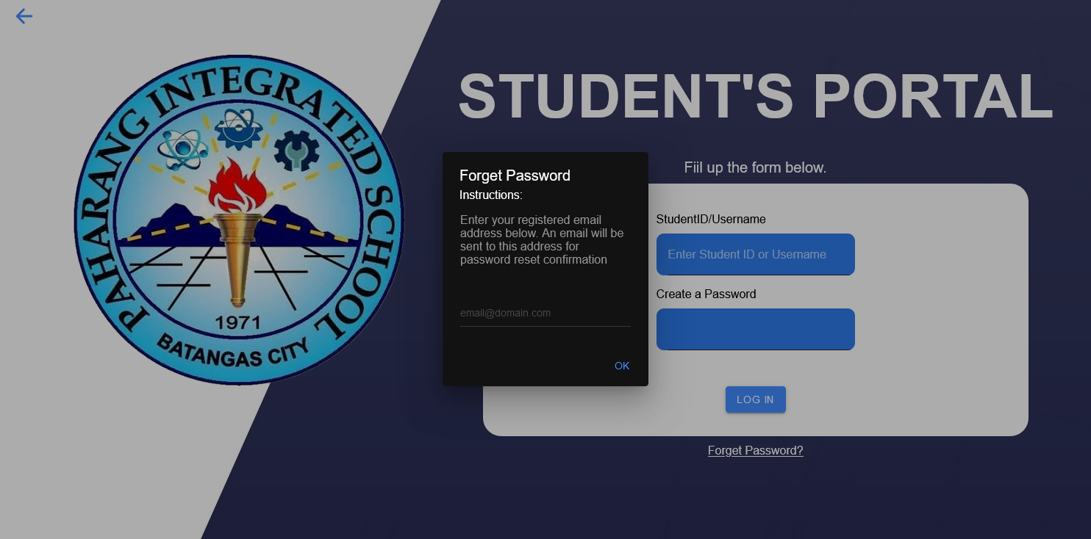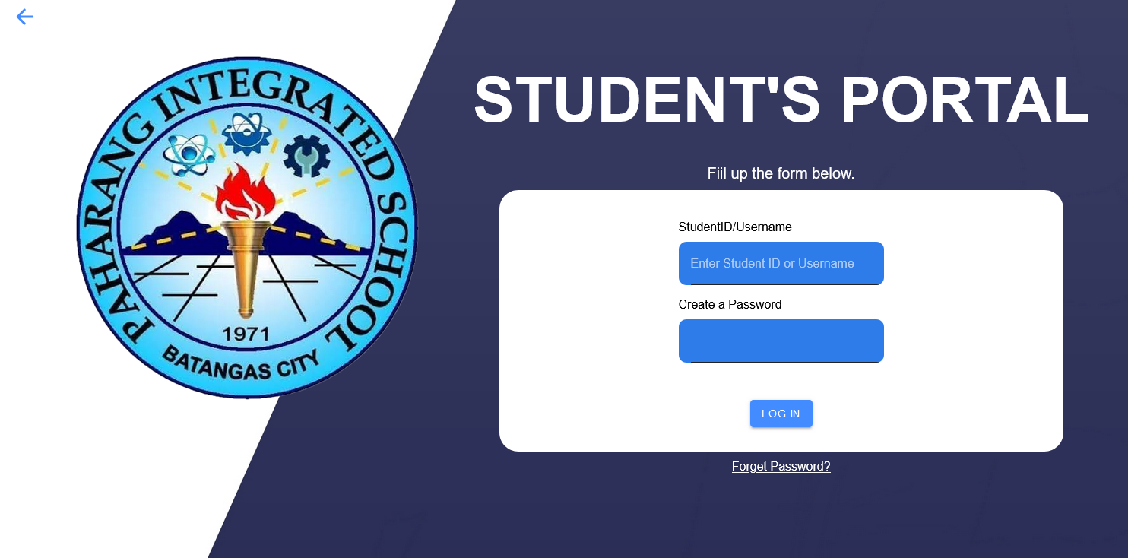

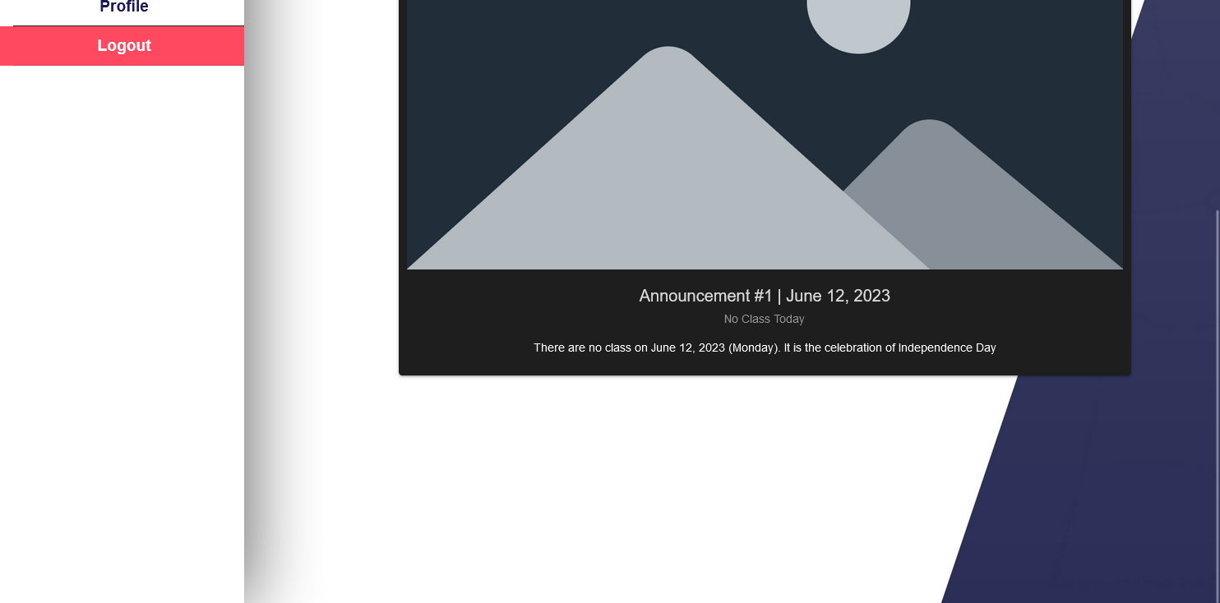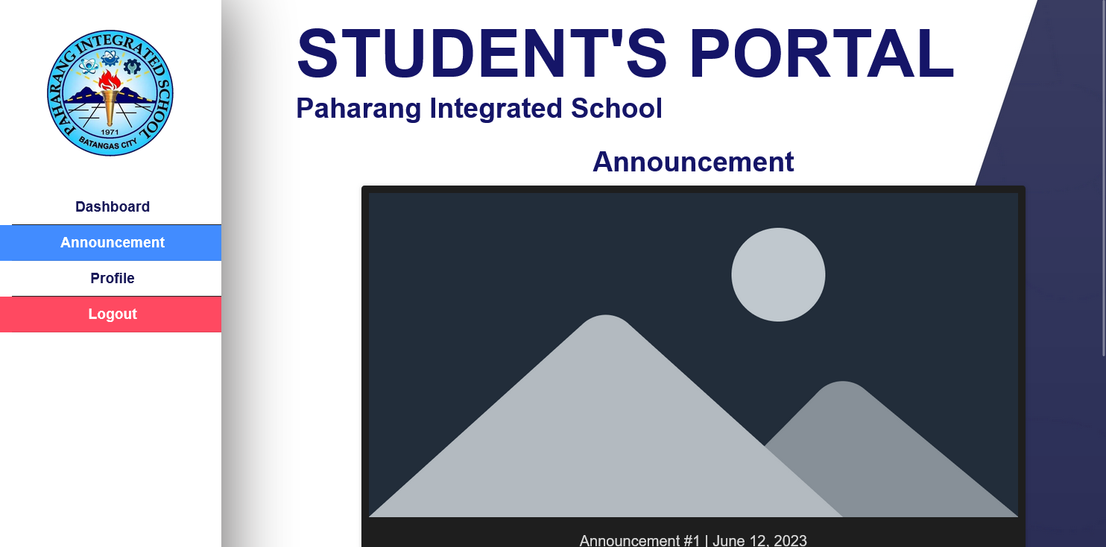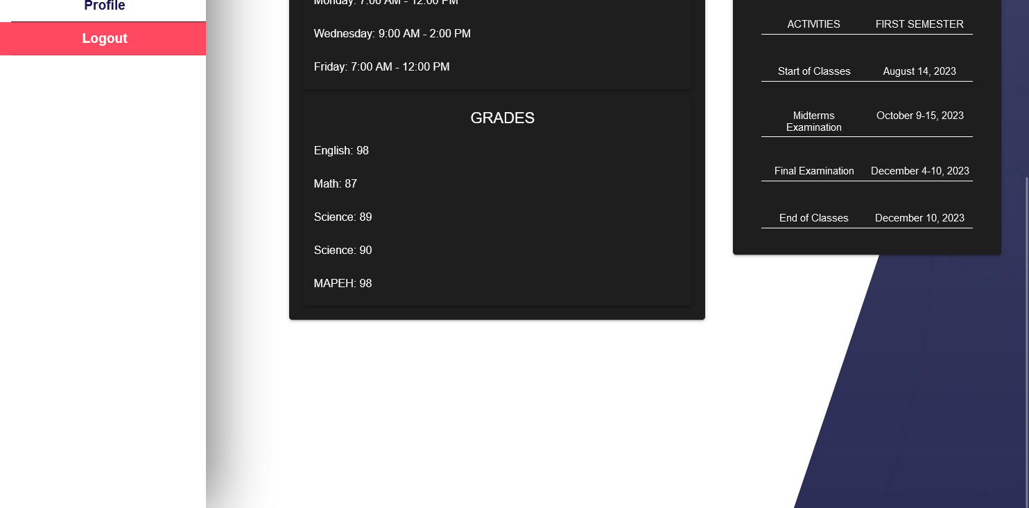

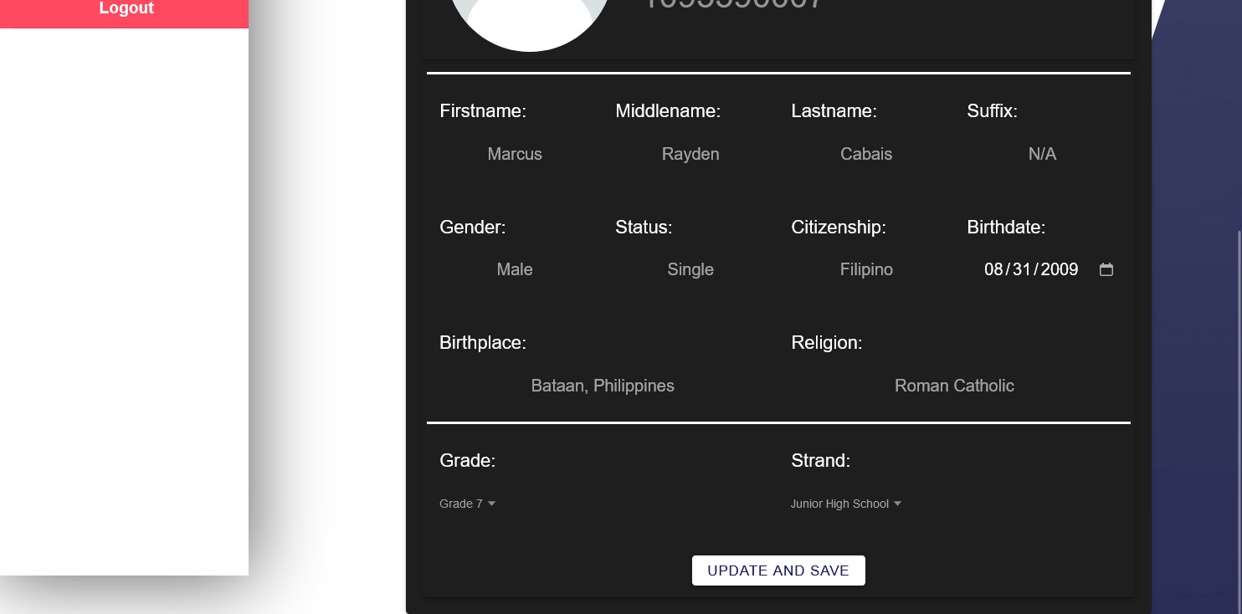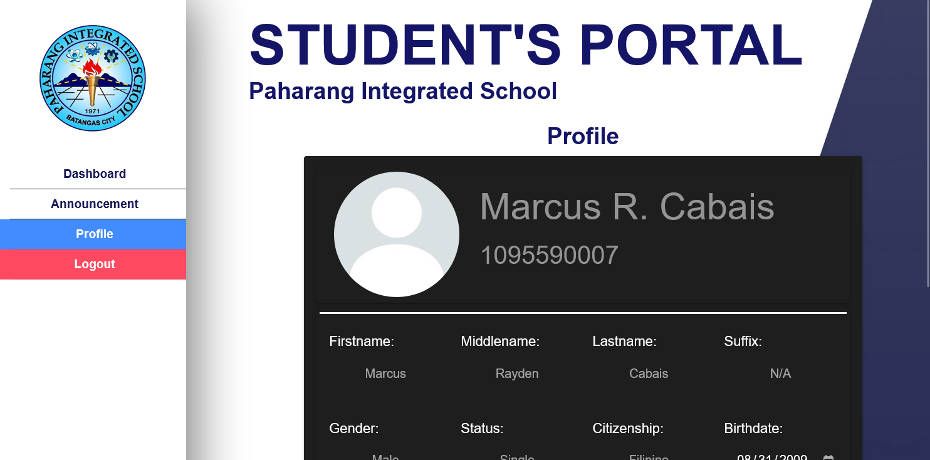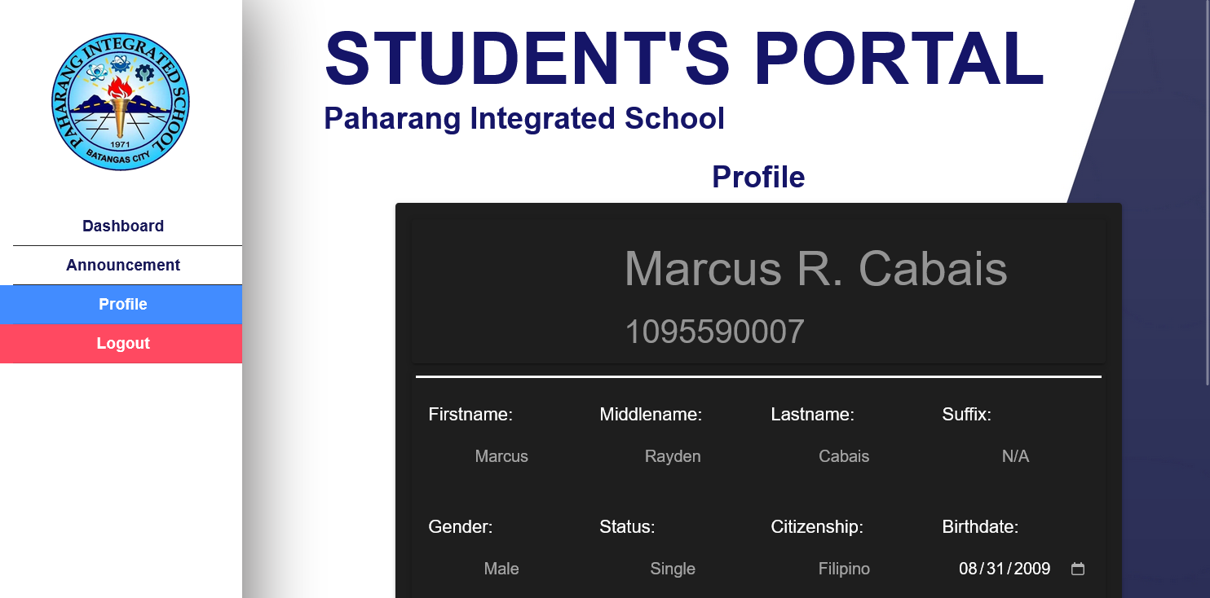

**IT 332: INTEGRATIVE PROGRAMMING AND TECHNOLOGIES**

**STUDENT MANAGEMENT SYSTEM FOR PAHARANG INTEGRATED SCHOOL**

**TEAM MEMBERS**



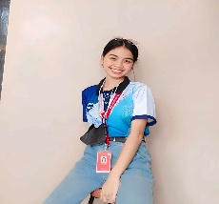

**CASAÑAS, KYLA E.**

**PROGRAMMER**

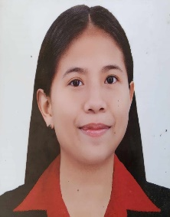

**MENDOZA, ALXIES MAE H.**

**DOCUMENTOR**

**ATIENZA, LAURENCE R.**

**DOCUMENTOR**

**IT 332: INTEGRATIVE PROGRAMMING AND TECHNOLOGIES**